Guest Author Biography

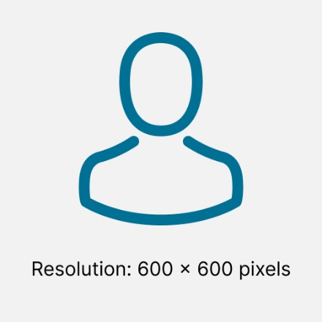 | Full Name  Title  Background information…
Format: JPG, PNG  Minimum resolution: 600 x 600 pixels | Max. 120 words

